**Network Fundamentals Week 5 Log Book**

**Summary**

We looked at how to work out the properties of a signal, including frequency, amplitude, period, max period, min period, bandwidth, attenuation and frequency domain.

**Implementation**

We used Microsoft excel to generate a spreadsheet with calculations that produced the results for max period, min period, bandwidth and attenuation based on the amplitude, frequency and period.

f(Hz) = frequency

A = amplitude

T = time (period)

**f = 1 / T or T = 1 / f**

A continuous signal containing the following components travels through different guided media.

**Every number in front of a sin is the amplitude of that component e.g. amplitude of the first one is 10.5**

**The number in front of the pi of which gives you the frequency of that component e.g. the frequency of the first one is 50**

**Period is worked out via**

**f = 1 / T or T = 1 / f**

**Max period is the highest period value**

**Min period is the lowest period value**

**Bandwidth is the range of the lowest and highest frequencies**

**Attenuation is 10dB/20 (this is the amount of loss of signal we get due to the copper used in the cable) e.g. for the example below where the attenuation is -10dB we have 10-10dB/20 which equals 0.316227766**

Each medium has a pass bandwidth, and introduces power attenuation as shown in table 1. All media have random noise levels between 2.5 and –2.5 volts. The signal components have phase distortions of /8, /4 and /2 respectively.

|  |  |
| --- | --- |
| Power attenuation | Bandwidth |
| -10dB | 120Hz |

### Table 1

**Results**

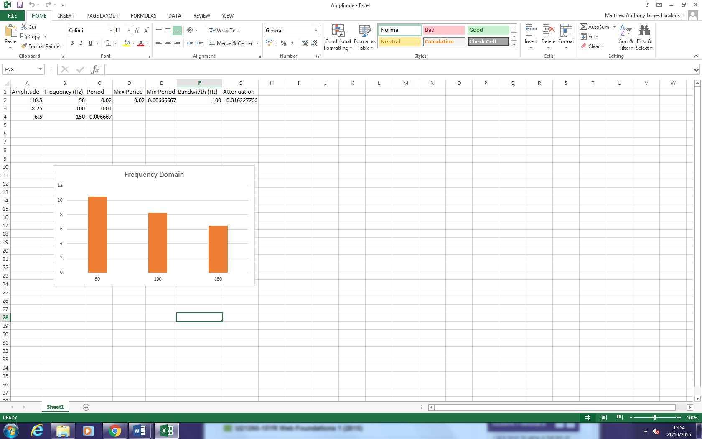

**Conclusion**

We worked out different properties of cables as well as how the relationships between them work.